CodeXtremeApps 2019 BrainStorming

<https://www2.imda.gov.sg/news-and-events/events-listing/Code-XtremeApps-2019/Open-Category>

<https://www.imda.gov.sg/-/media/imda/files/infocomm-and-media-buzz/cxa/cxa-2019/cxa-2019-challenge-statements.pdf?la=en>

Challenge Title: Clean Water & Sanitation

* Using technology to substantially improve water-use efficiency in Singapore, e.g. homes, schools and offices etc., and ensure sustainable usage and supply of freshwater to address water scarcity
* Support and strengthen the participation of local communities in improving water and sanitation management using technology

<https://www.programmableweb.com/category/water/apis?category=20412>

<https://news.itu.int/icts-ensure-sustainable-management-water-sanitation/>

<https://www.blockchainwater.ai/>

Filtering Water

Smart Water Tap

Challenge Title: Affordable & Clean Energy

* Significantly improve energy consumption in Singapore using technology
* Significantly improve energy production in Singapore using technology

<http://theconversation.com/the-future-of-blockchain-according-to-experts-in-the-energy-sector-111780>

Wifi Power Extender

Check for Not Energy Efficient Appliance App <https://nest.com/thermostats/>

Challenge Title: Industry, Innovation & Infrastructure **X**

* Increase the access of small and medium-sized enterprises (SMEs) and other enterprises to financial services, (for example affordable credit etc.)
* Increase the access of small and medium-sized enterprises (SMEs) and other enterprises to integrating into value chains and markets (for example expanding business through e-commerce, online to offline commerce, logistics etc.)

Challenge Title: Sustainable Cities & Communities

* Provide access to safe, affordable, accessible and sustainable transport systems for all, improving road safety, notably by expanding public transport, with special attention to the needs of those in vulnerable situations

<https://www.togetherforsaferroads.org/4-ways-technology-can-improve-road-safety/>

<https://www.mytransport.sg/content/mytransport/home/dataMall/dynamic-data.html>

Challenge Title: Responsible Production & Consumption

* Significantly reduce food waste at the retail and consumer levels and/or reduce food losses along production and supply chains using technology
* Encourage reducing, reusing or recycling through technology

<https://www.supplychaindive.com/news/food-waste-supply-chain-solutions/531509/>

Canned Food Vending Machine

Blockchain Food

Link Food Outlets, Log close to expired foods, Sell and Give Away

Smart Bin to Categorise Trash AI Smart Bin to Catergorise Trash

# Technologies Available

Android Studio

PHP, SQL, HTML, CSS, Javascript

Python, Tkinter

Unity

Android Studio

Web Application

* HTML, CSS, Javascript
* Python Flask
* NodeJS

Python

Augmented Reality

Blockchain

* <https://blockgeeks.com/guides/python-blockchain/>

Machine Learning / AI / Data Analytics

* Simple Linear Regression/ Classifier
* <https://ml5js.org/>

Internet of Things

Cyber Security

Big Data

Raspberry Pi/ Arduino/ ESP8266

Robot

<https://telegram.org/blog/bot-revolution>

<https://www.speedpost.com.sg/what-we-offer/POPStation.html>

# Ideas

Smart Home

* Remote Control Devices
* Hardware Needed: ESP8266
* <https://www.openhab.org/>
* AI help Automate your everyday life

# Winning Solutions in Previous Hackathons

<http://www.nas.gov.sg/archivesonline/data/pdfdoc/20170728011/WINNING%20SOLUTIONS%20FOR%20CODEXTREMEAPPS%202017%20HACKATHON%20UNVEILED.pdf>

<https://www2.imda.gov.sg/-/media/Imda/Files/About/Media-Releases/2017/Annex-C---Winners-List--Write-Ups-on-Solutions.pdf>

<https://www.imda.gov.sg/-/media/imda/files/about/media-releases/2018/annex-b-winners-list--write-ups-on-solutions.pdf?la=en>

# Technology Plan

Recycling and Reusability Bin (May be sorting)

Mini flea market that is online (Carousell but for useless old shit)

People put unwanted stuff into locker

Putter:

Raspberry Pi has camera to take photo of item

Input Details if needed

Locker Opens Door (Ultrasonic sensor to check if stuff is inside)

Receiver:

Reserve Item (Optional)

Reach there, select item to get (input key if needed)

Door Opens to get stuff

Locker has a Raspberry Pi to control which doors are opened (with Servos)

Ultrasonic Distance Sensor to check if stuff put inside

Sends Stuff to



After a certain length of days passes, if nobody claims the item, locker is opened and recycled

Suitable Items

1. Usable but Old Items
2. Recyclable Cardboard/ Paper/ Stuff
3. Old Clothes, Books, Electronic Gadgets

Details of item to be maintained in the database

1. Picture of it
2. Name
3. Category
4. Unique Identifier
5. Date placed inside
6. Description

Website

1. Users will be anonymous
2. Can view items on display

Things to note

1. What if 2 people claims the same item? > How to identify each of them if users are anonymous?
2. How to know if item that has been placed online has not already been taken? (User who sees item online goes to claim it but realises its already taken > wasted trip)

Software Overview

Carousell Like website

Raspberry Pi To Put and Remove Items from Database

# Half-Finalised Technology Plan

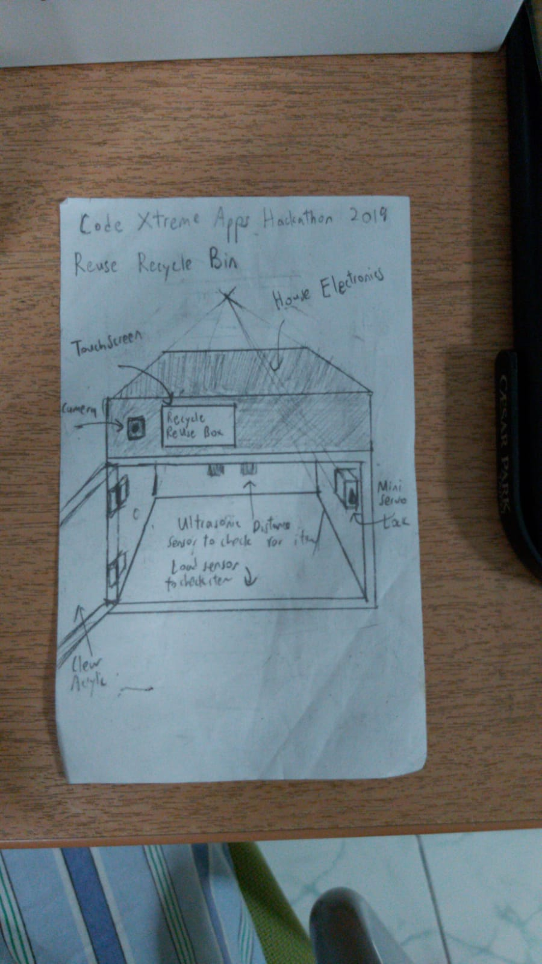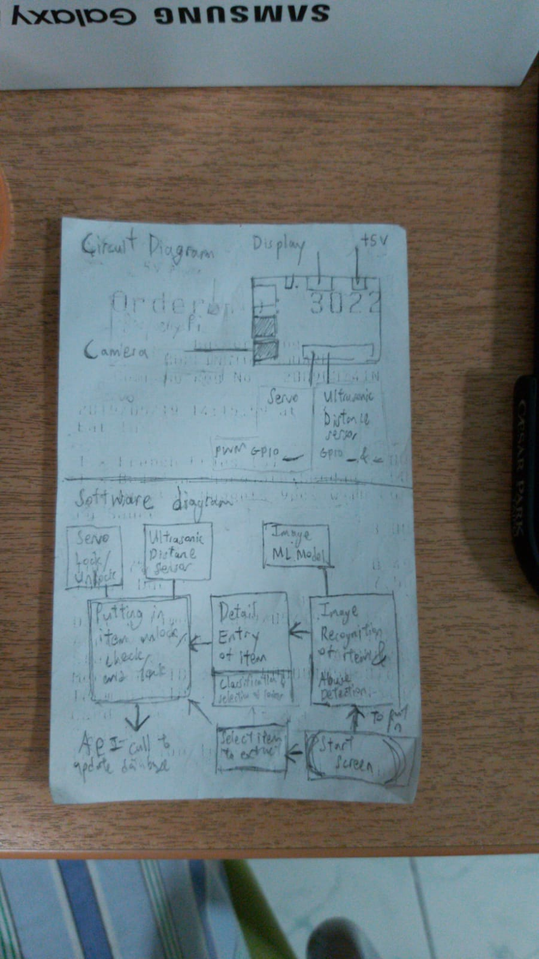

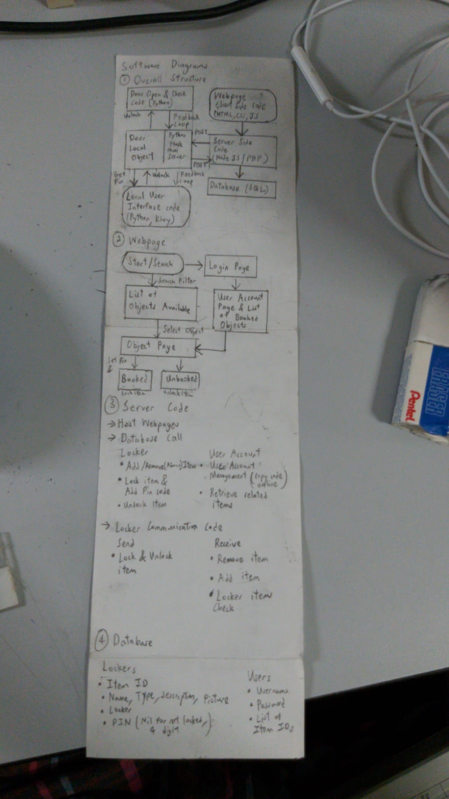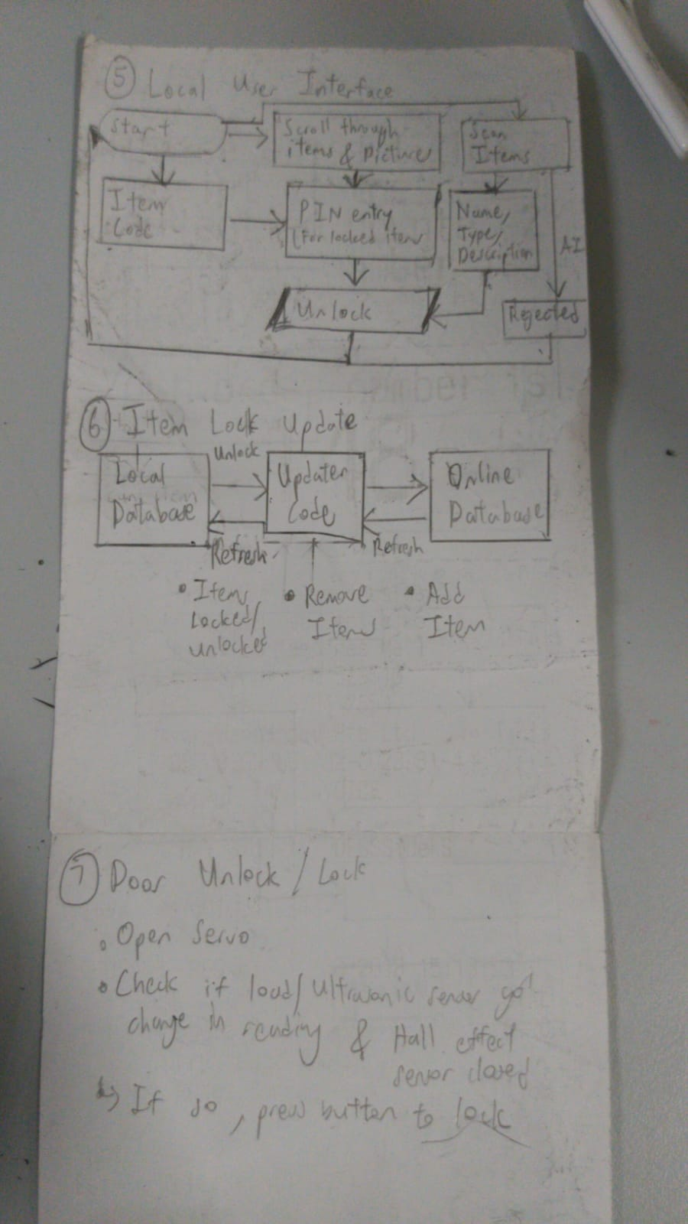

# Sample Projects to Copy Code from

<https://docs.google.com/presentation/d/1CsJqyUIjnGdq4Blvgl3mEme3-4OKJiQI-pz1n4L4ZYI/edit#slide=id.g561244ee1e_0_27>

<https://github.com/charliegerard/tfjs-recycling/blob/master/src/ImageRecognition.js>

<https://github.com/tensorflow/tfjs-models/tree/master/coco-ssd>

<https://medium.com/object-detection-using-tensorflow-and-coco-pre/object-detection-using-tensorflow-and-coco-pre-trained-models-5d8386019a8>

<https://medium.com/@karol_majek/10-simple-steps-to-tensorflow-object-detection-api-aa2e9b96dc94>